Architecture

* Landscape of a city with moving pieces

<https://blog.prusaprinters.org/how-to-print-maps-terrains-and-landscapes-on-a-3d-printer/>

* This can be done with conventional technique (and our print volume isn’t big enough to make it impressive)
* Counter the terrain can be printed in a FDM and we can place moving structures made from SLS on top. Also I don’t know how you can print something like this conventionally in any reasonable amount of time. You would need to craft it out of wood.
* 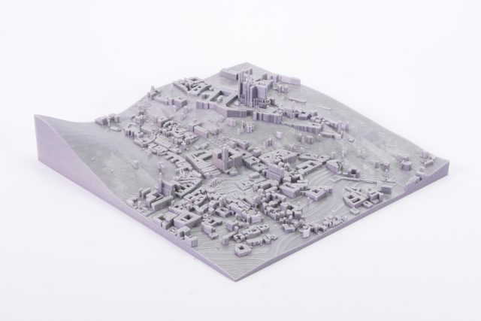

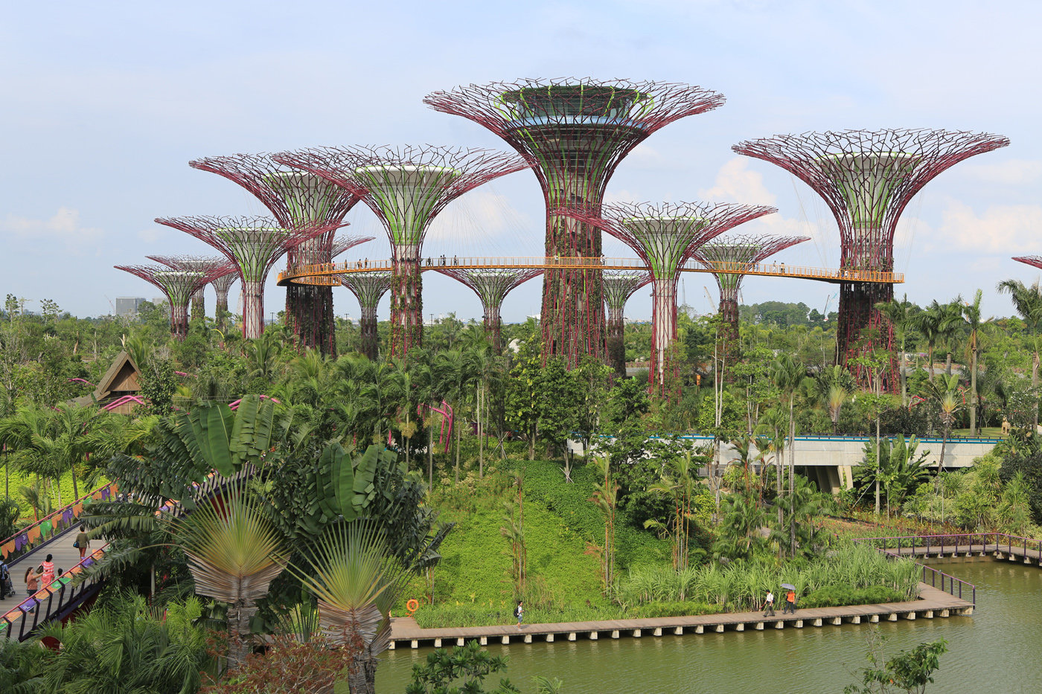

Using Generative Design to Build Structures like the one above would be awesome.

Other ideas from this link: <https://weburbanist.com/2013/09/16/sky-bridges-14-aerial-structures-that-span-skyscrapers/>

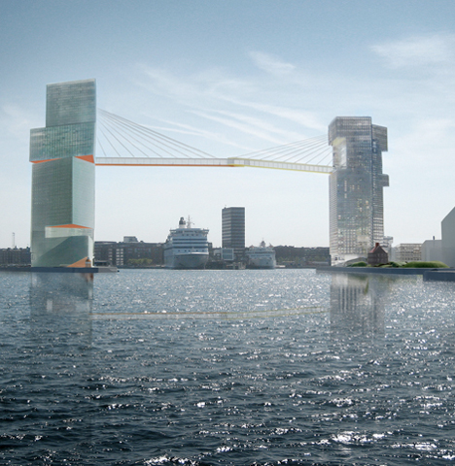

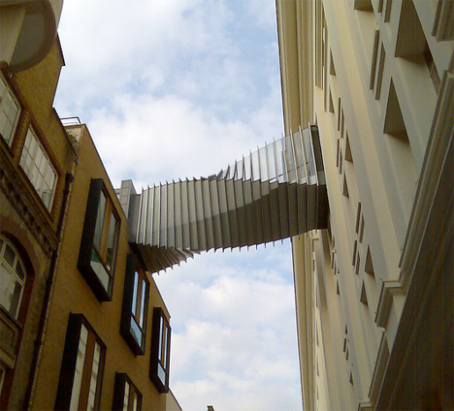

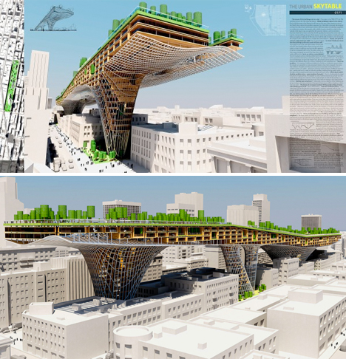

* [Sagrada Familia](https://commons.wikimedia.org/wiki/File:Model_of_La_Sagrada_Familia_-_Museum_of_the_History_of_Catalonia_-_Catalonia_2014_(4).JPG)
  + CAD will be difficult
* ETC building with moving elevators
  + This can be done with conventional manufacturing techniques too
  + <http://www.cadspan.com/fix-my-file/>
  + <https://wikis.utexas.edu/display/SOAdigitech/Exporting+from+Revit+for+3D+Printing>

Biomedical?

* Human skeleton with joints
  + CAD for this might be difficult

Engineering/Physics

* [Pythagoras cup](https://www.youtube.com/watch?v=A-YMHXuiaWw) with multiple cavities and internal tubes with unknown dimensions.
  + Might be good for a drinking game.
  + Example [here](https://www.stlfinder.com/model/pythagorean-cup-with-spiral-Uuf3FC6Q/8078042)
* Something with a mesh of chains
  + Foldable handheld fan: Something like [this](https://www.deluxe.com/products/promotional/folding-fan/24693/?&psc=KC632&s_kwcid=MARIN_24801%7cmkwid%7c%7cpcrid%7c413600349090%7cpdv%7cc%7cpkw%7c%7cpmt%7c%7c&gclid=CjwKCAiAhc7yBRAdEiwAplGxXwOy0UcUo7sVQ9hBDPby7xCDZ7aJ4xScVNjFBZyI_6OoxOC7qYFWiRoCpYkQAvD_BwE&gclsrc=aw.ds), except that the paper side will be made of nylon mesh or something
    - 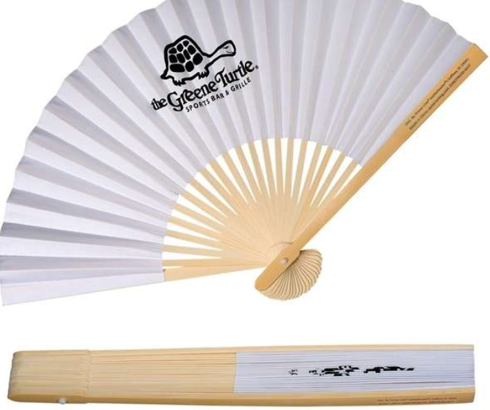
* 3D puzzle
* Generative design
  + Take a design/ set constraints and use generative design to get a truly unique model

Miscellaneous

* “Ship in a bottle”
  + Something fully built inside a container that is impossible to remove
* Russian Doll/ Nesting Toys
  + All built inside one another
* Expanding ball toy
  + <https://www.amazon.com/4Es-Novelty-Expandable-Expanding-Breathing/dp/B07N99K84Q>
  + 